

Coppull Neighbourhood Plan

Regulation 14 Consultation V3.9
August 2025


Contents

Foreword 3
1. Introduction 4
1.1 Planning for Coppull 4
1.2 Status of the Plan 4
1.3 Implementation, Monitoring and Review 4
2. Background and Aims 6
2.1 The Neighbourhood Area 6
2.2 Community and Stakeholder Engagement 7
2.3 Planning Aims 8
2.4 Format of Policies 8
3. Economy 9
Policy COP-1: Employment 12
4. Living 14
Policy COP-2: Housing 16
5. Community Facilities 17
Policy COP-3: Community Facilities 19
6. Environment 20
Policy COP-4: Green and Blue Infrastructure 21
7. Design 24
Policy COP-5: Design and Character 26
8. Movement 32
Policy COP-6: Transport and Active Travel 34
9. Flooding 35
Policy COP-7: Surface Water 36
10. Infrastructure priorities 37
11. Acknowledgements 38
12. Contacts 39

Foreword

Coppull has considerable potential, but also challenges for the next 10 years. This Neighbourhood Plan has been prepared to provide a planning policy framework for development over the next decade.

This Neighbourhood Plan has been prepared by Coppull Parish Council, with invaluable support from the Coppull Neighbourhood Plan Steering Group, which included Parish councillors and members of the local community giving their time on a voluntary basis. There has also been support from the Borough and County Councils.

The Neighbourhood Plan is concerned with the use and development of land. Policies are based on evidence and the outcomes of engagement with the local community. Issues addressed by the plan include housing, employment, community facilities, environment, design and movement. It is prepared against the context of climate change and the need to ensure that development is sustainable.

We are in no doubt that the plan cannot address all the matters brought up by the residents, but we have determination to make as much happen as possible to ensure the life of the village is pleasant, inclusive and enriches the lives of the diverse range of residents and businesses.

Introduction

Planning for Coppull

The Coppull Neighbourhood Plan is based on analysis of key issues and challenges facing the area. The policies in this Plan seek to address these issues and to guide development over the next decade. Policies are underpinned by socio-economic data and evidence relating to the local population, economy, housing, environment and other planning matters.

Status of the Plan

The Coppull Neighbourhood Plan, once made, forms part of the statutory development plan, together with the adopted Lancashire Core Strategy (July 2012) and The Chorley Local Plan 2012 – 2026, Site Allocations and Development Management Policies Development Plan Document (adopted 21 July 2015).

Section 38 of the Planning and Compulsory Purchase Act 2004 requires planning applications to be determined in accordance with the policies of the statutory development plan, unless material considerations indicate otherwise.

The Neighbourhood Plan does not deal with excluded matters including waste, mineral extraction or nationally significant infrastructure.

The Neighbourhood Plan will be in force from the date it is made until the end of 2035.

Implementation, Monitoring and Review

The Neighbourhood Plan will be used by Chorley Council as a basis for decision-making in the development management process. It would also be used in the appeals process. Coppull Parish Council will use the Neighbourhood Plan as a basis for making representations on planning applications and appeals.

The Plan will be monitored to assess its effectiveness in the development management process. Also, changes in national planning policy, local planning policy and local circumstances will be monitored and assessed. The Neighbourhood Plan will be reviewed and updated as and when necessary.

Map 1: Designated Coppull Neighbourhood Area

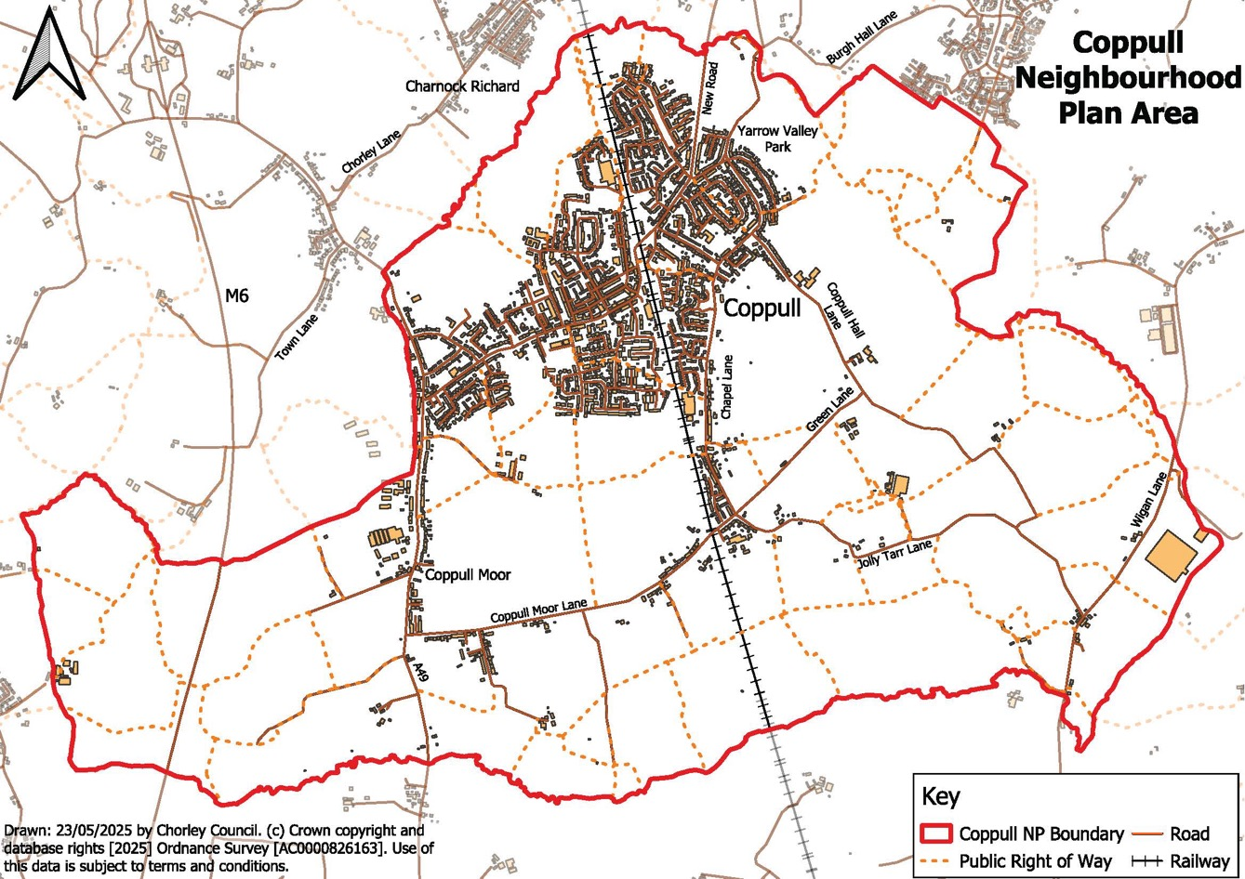

Background and Aims

2.1 The Neighbourhood Area

Coppull is a village and civil parish within the borough of Chorley, Lancashire; it is located between Chorley and Standish in the Greater Manchester area of Wigan and lies approximately 300 feet above sea level.

The village is bounded by water by way of Whittle Brook, Clancutt Brook, River Yarrow, Eller Brook, Hic-Bibi Brook and Stars Brook.

The precise location can be found here:
Latitude: 53° 37' 30.97" N
Longitude: -2° 39' 30.74" W

The village is served by good vehicular transport links via the A49 to the east, and the M6 and M61 motorways leading to countrywide access. The West Coast mainline runs through the centre of the village. However, Coppull does not have a railway station. There is currently one bus servicing the main village, which runs between Chorley & Wigan, although this does not operate through the Old Parish.

Coppull has a history of mining and cotton; today there are few traces of the Past apart from Ellerbeck and Hic Bibi which are redeveloped mining sites and Coppull Ring Mill, the only surviving cotton mill. This dominates Coppull’s skyline, providing a prominent landmark and providing a base from which local businesses operate. Yarrow Valley Weir is a remnant of the spinning industry and now boasts a salmon leap. Agricultural land is used primarily to grow crops within the village. Primary employment today is provided by the many retail shops throughout the village, several health care facilities, educational establishments and various small to medium commercial enterprises.

The census of 2021 recorded the population as 8304; Chorley BC Local Plan 2015 to 2026 characterises Coppull as an ‘Urban Local Service Centre’. The varied demographic indicates that Coppull is a good place to grow up, raise families and grow old.

Coppull is a pleasant area in which to live, work and visit, benefitting from several Nature Reserves and Open Green Spaces, along with access to bodies of water. Local people and visitors can ramble through a Nature Park, enjoy a quiet moment in one of the secluded gardens, stroll along country lanes enjoying panoramic views, or choose to watch the water and pond life in the brooks and reservoirs accessible from Coppull.

2.2 Community and Stakeholder Engagement

Engagement Activities

Engagement activities included:

- Initial residents’ meeting;
- Ongoing Parish Council newsletter articles;
- Facebook;
- Residents’ questionnaire;
- Use of the Place Standard tool (How Good is Our Place?);
- Later survey booklet;
- Pop Up Shops in all local pubs (at different stages);
- Resident meetings in local Legion covering transport & environmental;
- Business meetings in local Legion around any challenges they face
- Contact with all local schools.

Outcomes from Engagement

In terms of housing development, 42% favoured small developments of under 15 homes and 64% favoured reuse of brownfield sites.

Other issue raised included:

- Flooding and drainage;
- Infrastructure challenges when new developments are approved;
- Problems of water run-off, arising from recent development;
- Protection of heritage of village;
- Conservation of red brick terraces that are original to Coppull;
- Lack of access to public transport.

These key issues and other more detailed issues raised have informed the aims and policies of the Neighbourhood Plan, underpinned by relevant data and evidence, as set out in the policy rationales.

A number of issues outside of the scope of the Neighbourhood Plan were also raised, so will be addressed by other means. These included traffic speeding and management, pedestrian safety on the existing road network, parking, highway improvements, internet and reopening of a railway station.

2.3 Planning Aims

The Coppull Neighbourhood Plan has the following planning aims:

- To help ensure that development is sustainable, against the context of climate change;

- To support local employment opportunities, including homeworking;

- To help provide housing to meet local need, supported by range of community facilities;

- To help preserve or enhance Coppull’s green and blue infrastructure;

- To support high quality and sustainable design, to reinforce Coppull’s distinctive identity;

- To support sustainable and safe transport and active travel.

2.4 Format of Policies

The following chapters contain planning policies. The structure of the following policies is as follows:

Planning Rationale (concise summary of the evidence and justification behind the policy)
The policy (requirements for development proposals to meet)
Interpretation (notes on how the policy should be applied)

The policies cover a range of issues as follows:

COP-1: Employment
COP-2: Housing
COP-3: Community Facilities
COP-4: Green and Blue Infrastructure
COP-5: Design and Character
(with Green Guidance Note)
COP-6: Transport and Active Travel
COP-7: Surface Water

Collectively, the policies put in place a design code, in particular in parts of COP-2, COP-4, COP-5 and the Green Guidance Note, and COP-6.

Economy

Planning Rationale

Chapter 6 of the National Planning Policy Framework 2023 (NPPF) deals with building a strong, competitive economy and the need to create conditions for businesses to invest, expand and adapt. Chapter 7 refers to the role that retail centres play at the heart of local communities.

The Central Lancashire Core Strategy July 2012 includes the following policies:

Policy 1: Locating Growth
Policy 9: Economic Growth and Employment
Policy 10: Employment Premises and Sites
Policy 11: Retail and Town Centre Uses and Business Based Tourism
Policy 13: Rural Economy

The Plan identifies Coppull as a Local Service Centre and supports some growth and investment.

The Chorley Local Plan 2012 – 2026, Site Allocations and Development Management Policies Development Plan Document (adopted 21 July 2015) includes the following policies:

Policy EP3: Development Criteria for Business and Industrial Development
Policy EP4: Employment Development in Residential Areas
Policy EP7: Development and Change of Use in District and Local Centres
Policy EP8: Existing Local Shops

The following Employment policy is intended to augment these policies, adding a local dimension.

It is important to maintain employment uses in Coppull, so that there are local economic opportunities for more people. COVID created permanent changes in live-work patterns, with more people working from home, at least for part of the week.

Key employment and industrial sites in Coppull include:

- Coppull Mill;
- Moss Lane;
- Baker Street;
- Chapel Lane industrial site;
- Blainscough Lane industrial site;
- Spendmore Lane (all retail);
- Various smaller sites.

The operation and expansion of Coppull Mill is welcomed, but there are concerns over the adequacy of access roads and parking (the intention is to upgrade the surface carpark). Where there are other commercial uses and residential accommodation in close proximity to commercial sites, it is necessary to consider and manage potential conflicts.

The Chorley Local Plan identifies Coppull Local Centre, based around Spendmore Lane. The nature of this centre is quite dispersed, with sections, with some housing between commercial uses.

The High Street Task Force has identified 25 priorities for high street recovery and the most relevant to planning policy are:

Priority | Neighbourhood Plan Response
Area development strategies | The NP provides a policy framework for the Neighbourhood Area.
Improving image | The following Employment Policy supports regeneration, improvement of employment sites, high street and rural diversification.
Visual appearance | The NP’s Design and Green and Blue infrastructure policies deal with quality of environment.
Attractions, entertainment, non-retail offer, leisure offer | The following Employment Policy supports diversification.
Walkability, connectivity | The NP’s Design and Active Travel Policies place emphasis on pedestrian connectivity and permeability.
Recreational areas, public space, open space | The NP’s Design and Green Infrastructure policies place emphasis on quality spaces.
Mixed use | The NP policies support mixed use, including employment, residential and community facilities in walkable distance.
Planning blight, regeneration | The NP places emphasis on regeneration, including development of brownfield sites.
The role of the centre | Coppull is identified as a Local Centre. Its role is primarily to serve the local population, including retail, community facilities, recreation and food and drink.

Policy COP-1: Employment

- Support will be given to the expansion or improvement of Coppull’s existing employment and industrial sites, subject to:

- there being adequate access, servicing and car-parking;
- there being no significant adverse impact on the amenities of residential properties by reason of noise, dust, vibration, visual impact, smell, traffic disturbance or other impacts.

- New employment space, including facilities to enable home working and flexible working, will be supported within the built areas of Coppull, subject to:

- there being adequate access, servicing and car-parking;
- there being no significant adverse impact on the amenities of residential properties by reason of noise, dust, vibration, visual impact, smell, traffic disturbance or other impacts.

- Retail and other high street uses will be supported in and around Coppull Local centre, subject to:

- maintaining or enhancing the viability and vitality of the Local Centre;
- there being no significant adverse impact on the amenities of residential properties by reason of noise, dust, vibration, visual impact, smell, traffic disturbance or other impacts.

- Support will be given to the diversification of farms and agricultural buildings, subject to:

- there being no significant loss of the best and most versatile agricultural land;
- there being adequate access, servicing and car-parking;
- there being no significant adverse impact on the amenities of residential properties by reason of noise, dust, vibration, visual impact, smell, traffic disturbance or other impacts.

Interpretation

The policy supports the expansion or improvement of local employment opportunities.

In considering the expansion or improvement of Coppull’s existing employment and industrial sites (clause 1), any existing traffic or amenity problems should be taken into account.

Employment and enterprise sites include:

- Coppull Enterprise Centre (Coppull Mill), Mill Lane;
- Chapel Lane Business Park, Chapel Lane;
- Various single employer sites.

In considering access, servicing and car parking, the policy should be applied closely with Policy COP6, in addition Local Plan policies. Design, environment and other requirements for employment development are dealt with in later policies in this Plan.

Coppull Local Centre is defined in the Chorley Local Plan.

Support for local and home working could include enterprise space with rental or hot desks, meeting space and printing and other facilities.

For green belt sites, the policy should be interpreted as supporting only appropriate development in the green belt, as defined in the National Planning Policy Framework.

4. Living

Planning Rationale

Chapter 5 of the NPPF deals with supply of homes, mix and affordability.

The Central Lancashire Core Strategy July 2012 includes the following policies:

Policy 4: Housing Delivery
Policy 6: Housing Quality
Policy 7: Affordable and Special Needs Housing

The Chorley Local Plan 2012 – 2026, Site Allocations and Development Management Policies Development Plan Document (adopted 21 July 2015) includes the following policies:

Policy HS1: Housing Site Allocations
Policy HS4A: Open Space Requirements in New Housing Developments
Policy HS4B: Playing Pitch Requirements in New Housing Developments
Policy HS6: Replacement Dwellings
Policy HS7: Rural Infilling
Policy HS8: Rural Affordable Housing - Rural Exception Sites
Policy HS9: Conversion of Rural Buildings in the Green Belt and Other Designated Rural Areas
Policy HS10: Agricultural Workers’ Dwellings in the Countryside
Policy BNE3: Areas of Land Safeguarded for Future Development Needs

The following Housing policy is intended to augment these policies, adding some detail. The policy seeks to shape affordable housing, but not to amend requirements in terms of thresholds and proportions.

Housing development needs to address local needs and to provide a high standard of accommodation. The emerging Local Plan is likely to use safeguarded sites from the previous Local Plan as a basis for site allocations. The Neighbourhood Plan does not make site allocations, but does support the development of housing on brownfield sites and though infill, redevelopment or conversions.

The Parish currently has three care homes and sheltered accommodation.

The Chorley Council Housing Need and Demand Assessment August 2022 identifies a district-wide need for affordable housing and accommodation for first-time buyers and older people. Engagement with estate agents in Coppull similarly identifies a need for affordable housing, accommodation for first time buyers and older people, including those looking to downsize.

Local Plan site allocations include the following in the Neighbourhood Area:

Site Ref. | Location | Area (ha) | Progress by 2024
HS1.33 | Discover Leisure, Chapel Lane | 3.9 | Site developed
HS1.34 | Regent Street | 0.5 | None
HS1.35 | Land at Northenden Road | 1 | Site developed
HS1.36 | Coppull Enterprise Centre, Mill Lane | 1.3 | Site developed
HS1.37 | Clancutt Lane | 1 | Site developed
HS1.38 | Mountain Road | 0.8 | None

Local Plan safeguarded sites in Coppull are as follows:

BNE3.5 North of Hewlett Avenue, Coppull
BNE3.6 Blainscough Hall, Coppull

These sites are expected to be allocated in the next revision of the Local Plan. However, planning permission has been granted already for these sites.

For Coppull, in the emerging Chorley Local Plan, there are 4 proposed housing allocations which result in a housing requirement figure of 207 dwellings over the Plan period. Chorley Council has confirmed that these would meet housing need for the Parish. IN addition, the following policy COP-2 supports residential development through brownfield sites, infill, redevelopment and building conversions. The Neighbourhood Plan therefore exceeds housing need.

Policy COP-2: Housing

- Residential development will be supported in the following locations:

- Redevelopment of brownfield sites;
- Infilling of gaps in existing built frontages in the built area of Coppull;
- Redevelopment of existing dwellings, providing it does not involve the loss of a heritage asset;
- Building conversions, providing it does not involve the loss of existing employment space or community facilities.

- Residential development should include a mix of accommodation based on the latest evidence of local need and particular support will be given to:

- housing with superior environmental performance, enabling lower running costs;
- specialist housing to support independent living for older people or people with limited mobility or other special needs;
- smaller housing suitable for first time buyers or those seeking to downsize.

- New-build residential development should include, where possible:

- Private or shared garden or other external amenity space;
- Screened storage space of bins and recycling, located where possible away from street frontages;
- Secure and covered storage space for cycles or personal vehicles.

- Where affordable housing is required, where possible it should be provided as an integral part of the development and be of similar design and specification as market housing, so that it is tenure blind.

Interpretation

For green belt sites, the policy should be interpreted as supporting only appropriate development in the green belt, as defined in the National Planning Policy Framework.

Design, environment and other requirements for housing development are dealt with in later policies in this Plan.

The requirements for residential development in terms of amenity space and storage apply to new build housing. Such requirements will be applied flexibly to residential development involving the conversion of upper floors or of existing buildings.

Storage space for cycles could include separate spaces or be provided as part of garage space. For apartment type development, a shared facility could be provided.

Community Facilities

Planning Rationale

Chapter 8 of the NPPF deals with promoting healthy and safe communities. Planning policies should aim to achieve ‘healthy, inclusive and safe places’. This includes promoting social interaction, being safe and accessible, and enable and support healthy lifestyles. Policies should also make provision for shared spaces and community facilities and guard against loss of valued facilities and services. Local Green Space, including criteria for designation, is dealt with in Paragraphs 100-103.

The Central Lancashire Core Strategy July 2012 includes the following policies:

Policy 24: Sport and Recreation
Policy 25: Community Facilities

The Chorley Local Plan 2012 – 2026, Site Allocations and Development Management Policies Development Plan Document (adopted 21 July 2015) includes the following policies:

Policy HW2: Protection of Existing Open Space, Sport and Recreational Facilities
Policy HW6: Community Facilities

The following Community Facilities policy is intended to reinforce these policies, providing general support for new or improved community facilities.

Coppull has a good mix of community facilities, including recreation and sports facilities, shops, food and drink, library and other building-based facilities.

Local community facilities at the time of writing include:

- Health facilities, including doctors’ surgery, clinic, private dentist and pharmacy;
- Recreational facilities, including Springfield Park Leisure Centre, football pitches, a rugby pitch (Chorley Panthers), BMX circuit and two livery stables;
- Clubs, including the Coppull and Standish brass band Club room, British Legion club and Conservative club, with a bowling green;
- 4 churches, including communal halls;
- The Parish Council village hall;
- A range of retail, pubs and other food/drink facilities;
- Dry cleaners, vet, post office, bakers, florist, estate agents, angling shop and various hairdressers and barbers,
- A library and police station;
- Primary schools with nursery provision and a private nursery;
- A repair garage, tyre fitters and used car sales;
- Three garden centres, allotments and farms with shop outlets;

Facilities which are not currently provided locally, and which would be welcomed include a butchers, NHS dentist, opticians and filling station.

Maintaining or enhancing the range of local facilities creates sustainable and walkable neighbourhoods.

Policy COP-3: Community Facilities

- Development to provide new community facilities or to improve or diversify existing community facilities will be supported, subject to:

- there being adequate access, servicing and car-parking;
- there being no significant adverse impact on the amenities of residential properties by reason of noise, dust, vibration, visual impact, smell, traffic disturbance or other impacts.

Interpretation

The policy applies to a range of community facilities, including those in Use Classes E, F1 and F2, examples being:

- business-based community facilities, such as shops and cafes;
- public facilities, such as public meeting or leisure facilities;
- health and fitness facilities;
- land-based facilities, such as sports pitches, allotments and play areas.

Design, environment and other requirements for community facility development are dealt with in later policies in this Plan.

6. Environment

Planning Rationale

Chapter 15 of the NPPF deals with conserving and enhancing the natural environment. Planning policies should protect and enhance valued landscapes, intrinsic character and beauty of the landscape, habitats, and provide net gains in biodiversity.

The Central Lancashire Core Strategy July 2012 includes the following policies:

Policy 18: Green Infrastructure
Policy 22: Biodiversity and Geodiversity
Policy 31: Agricultural Land

The Chorley Local Plan 2012 – 2026, Site Allocations and Development Management Policies Development Plan Document (adopted 21 July 2015) includes the following policies:

Policy BNE9: Biodiversity and Nature Conservation
Policy BNE10: Trees
Policy BNE11: Species Protection

The following Green and Blue Infrastructure policy is intended to augment these policies, adding a local dimension.

Coppull’s urban core is surrounded by rural or urban fringe land. Within the urban area, there are a range of green areas and corridors and water features, including country parks, nature reserves, hedgerows, woodland, trees, rivers, brooks, ponds, and wildlife corridors. These have value for biodiversity and wildlife. They are also important in supporting recreational uses and active lifestyles, supporting good physical and mental health.

The Chorley Open Space, Sports and Recreation Strategy Action Plan 2020 to 2036 highlights the value of green spaces and facilities and identifies key spaces in Coppull. Coppull’s blue and green spaces are also identified in the Coppull Parish Neighbourhood Plan - Analysis of Green and Blue Assets in Coppull, February 2024.

The following policy addresses the range of blue and green infrastructure identified and seeks to ensure that the impacts of development on the key qualities of different spaces and features are considered in decision making.

Policy COP-4: Green and Blue Infrastructure

- Development of the Country Parks, public parks and public gardens will be supported, providing:

- it is required to support the recreational use or operational management of the facility;
- it would maintain or enhance the green and open character and the landscape, community, wildlife or recreational value of the facility;
- there is no significant impact on the amenities of residential properties by reason of noise, dust, vibration, visual impact, smell, traffic disturbance or other impacts.

- Development should preserve and avoid causing harm to:

- the river Yarrow and its banks and environs;
- the network of local brooks and their environs;
- Coppull’s historic industrial ponds and their environs.

- Development should not cause any significant harm to the amenity or recreational values of Coppull’s formal and informal green and open spaces.

- Development should take opportunities to create biodiversity net gain and should avoid harm to habitats, including nature reserves and wildlife corridors.

- Development should avoid any harm or encroachment onto Coppull’s woodlands and should retain mature trees and hedgerows and incorporate them into the design and layout of development schemes.

- Development to enable local food growing will be supported, including allotments and community gardens and orchards.

Interpretation

The policy seeks to protect green and blue infrastructure, and this should include consideration of impacts on the recreational, wildlife, biodiversity, amenity, character and other values.

Key green spaces with particular amenity and recreational value include:

- The ‘Railway Triangle’, between Station Rd and Spendmore Lane;
- The Green in front of the Printer’s Arms Pub, Chapel Lane;
- land linked to Berry’s Garden;

Land off Bogburn Lane and Crane Street.

Nature reserves include the Hic Bibi local nature reserve, Chisnall Hall nature reserve and Blainscough Nature Reserve. Country Parks include the Yarrow Valley Country Park (part only is within the parish).

The policy enables appropriate development to support the management and operation of country parks, public parks and public gardens.

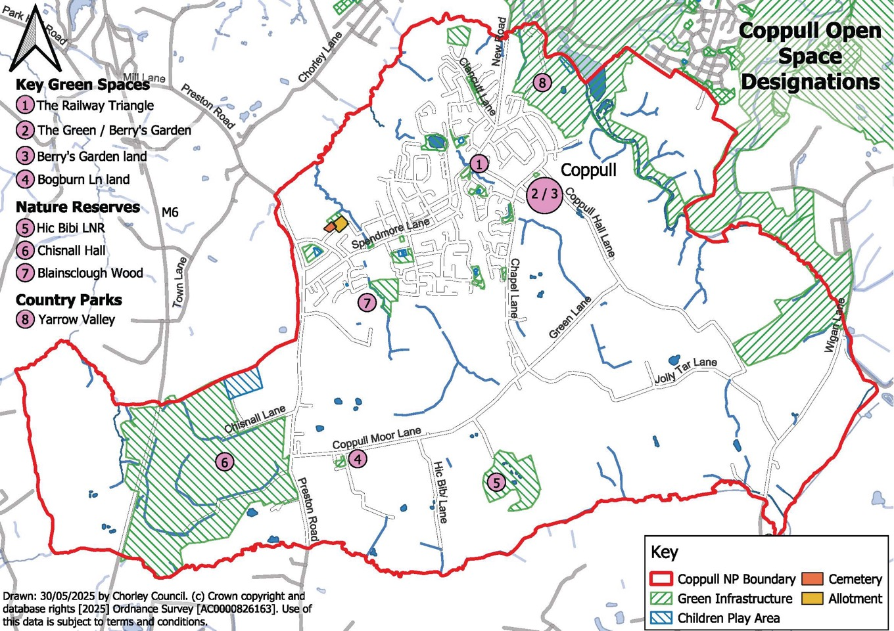

Design

Planning Rationale

Chapter 12 of the NPPF deals with achieving well-designed places. Design considerations include function, adding to the quality of the area, visual attractiveness, effective landscaping, being sympathetic to local character and history, not discouraging innovation and change, maintain strong and distinctive sense of place, optimise site potential, and making safe, inclusive and accessible places. Chapter 16 deals with conserving and enhancing the historic environment. This includes consideration of sustaining or enhancing heritage assets, wider social, economic and cultural benefits, contribution of new development, and character of place.

The National Design Guide (2021) establishes that well-designed places have ten characteristics. These are context, nature, identity, use, resources, movement, built form, public space, homes and buildings and lifespan.

The Central Lancashire Core Strategy July 2012 includes the following policies:

Policy 16: Heritage Assets
Policy 17: Design of New Buildings
Policy 27: Sustainable Resources and New Developments

The Chorley Local Plan 2012 – 2026, Site Allocations and Development Management Policies Development Plan Document (adopted 21 July 2015) includes the following policies:

Policy BNE1: Design Criteria for New Development
Policy BNE8: Protection and Enhancement of Heritage Assets
Policy HW1: New Open Space, Sport and Recreational Facilities

The following Design and Character policy is intended to augment these policies, adding detail and a more local focus, especially on character, and supporting green design.

The design of development has implications for safety, convenience, ease of movement, quality of life and physical and mental health. Quality of environment is a key factor in creating places where people want to live, work, visit and invest. Good design can also create facilities that are easier to maintain, and cheaper to run.

In addition, well designed development can reinforce the distinctive local identity of Coppull. The late 19th century and early 20th century core in particular has a locally distinctive ‘red brick’ industrial village character, including domestic terraces, public buildings, commercial buildings and industrial buildings. Some are listed buildings. The following policy includes a design code for this distinctive character area.

Much recent development is generic in nature, so does little to reinforce Coppull’s distinctive identity. Other problems include:

- poor public realm (overuse of blacktop and lack of green infrastructure),
- vehicular entrances through buildings, past house frontage;
- Layouts that require blank high walls and fences next to the highway;
- ‘anywhere’ house types.

Building for a Healthy Life (previously Building for Life 12) is a design toolkit for housing schemes and has informed the following design policy.

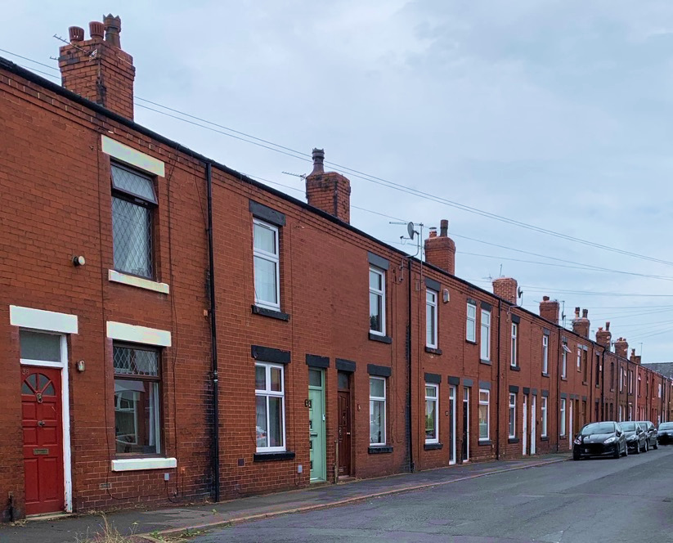
Traditional Terraced Housing in Coppull, which is part of the red brick core.

Policy COP-5: Design and Character

- Development should provide a safe, convenient and attractive environment for people, meeting the following requirements proportionate to the scale and nature of the scheme:

- provide active frontages with doors and windows or low walls to street frontages, to provide overlooking and natural surveillance;
- avoid high fences and other inactive frontages to surrounding streets and spaces;
- create permeable layouts for pedestrians and cyclists, including connections to existing footpaths and cycleways around the site.
- provide attractive public spaces designed to support recreational and social interaction as an integral part of the design and layout;
- include street and garden trees, hedges, landscaping and other green infrastructure.

- Development should take opportunities to include positive design features to reduce carbon use and enhance biodiversity, taking account of the following Green Guidance Note (Pages 28-30), and support will be given to innovative or creative green design solutions, designed for the specific site and context.

- Development should complement the surrounding context in terms of the height, massing, scale, set-back from the road and any existing patterns of yards or garden space.

- Development in and around Coppull’s historic core character area (see Map 3) should complement the locally distinctive identity and character, including:

- the industrial vernacular of red brick, plain clay tiles and timber windows, used in a combination of terraced housing, industrial, commercial and other public buildings;
- townscape character based on rear-of-pavement terraces or frontages set back behind small front courts or gardens;
- landmark historic churches and their churchyard settings, including walls, gates, graves and trees.
- boundary treatments comprising low brick walls and hedges.

- Development that would improve the settings of listed buildings will be supported, including enhancement of car-parking areas.

Interpretation

The policy deals with different aspects of design, including pedestrian convenience, quality of public realm, local distinctiveness, character, and green design. Policy COP6 also addresses active travel (walking and cycling).

The intention of the policy is to challenge poor design and some of the problems with recent housing schemes, including avoid blank tall fences adjacent to the road, excessive use of blacktop surfaces, generic houses and layouts.

The policy highlights the late 19th and early 20th century urban core of Coppull, which still provides the main focus for the village.

The policy should not be interpreted as requiring stylistic imitation or suppressing creativity and innovation.

Map 3: Coppull Historic Core Character Area

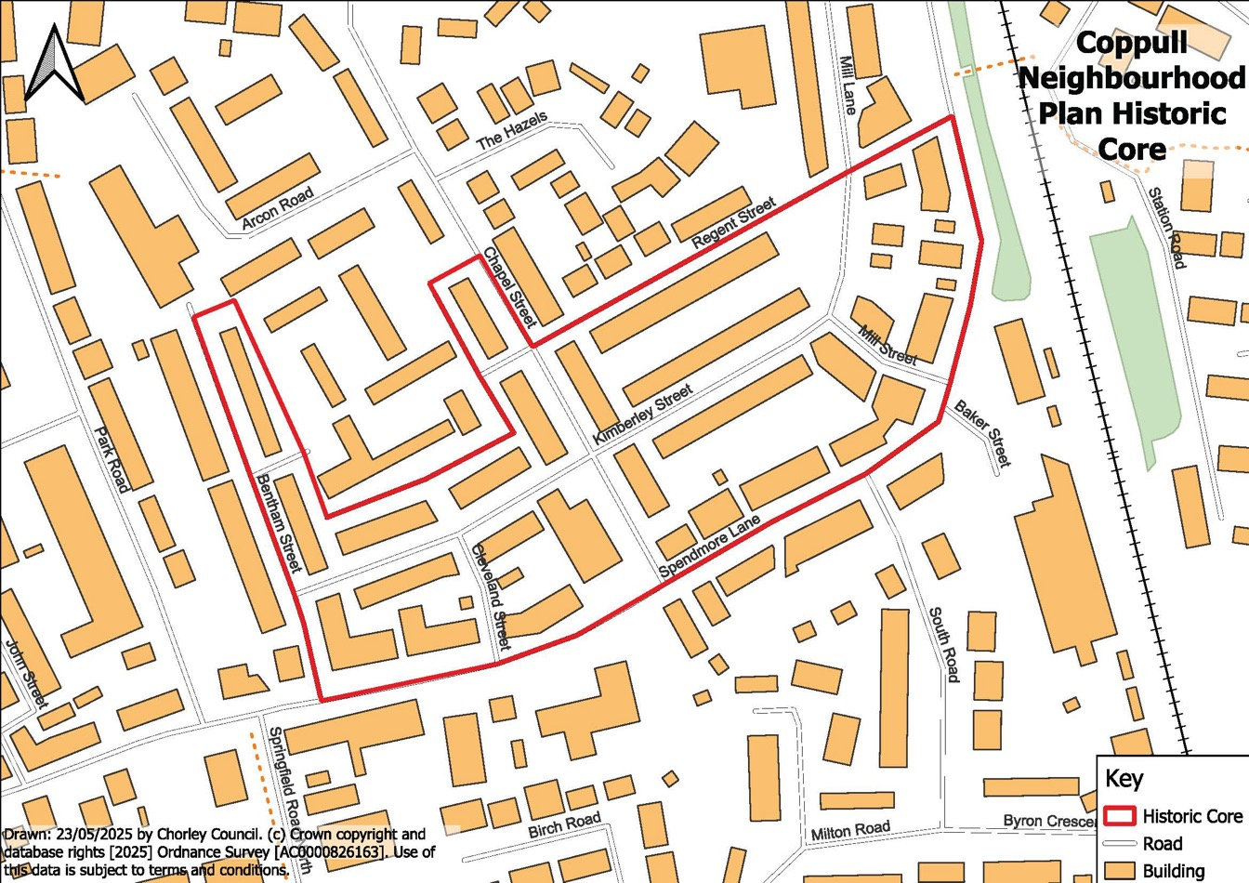

Green Guidance Note

This is a guidance note for developers on green design. It has been written to augment and help secure compliance with the policies of the neighbourhood plan, in particular those relating to design and environment.

Planning Principles

Mixed use neighbourhoods (which include residential properties, employment and community facilities in easy walking distance) help to reduce the need for journeys. Coppull already has mixed-use neighbourhoods (with a concentration of community facilities in the centre), pedestrian-orientated layouts and dense urban forms such as terraced housing. This helps to make Coppull a walkable neighbourhood.

Layouts in new development should complement this and prioritise pedestrian and cycle movement, convenience and safety. This includes convenient links to public transport.

Flexible work practices, including home working, can help to create more sustainable live/work patterns. Many meetings can be held through digital media.

Retention and reuse of buildings preserves the energy embodied in their materials and construction and avoids landfill.

Design of development should be designed for the specific site and context, including:

- Preserving trees and hedges in the layout and design;
- taking account of microclimate, including sun, shading and wind;
- avoiding high flood risk areas or incorporating design features to mitigate flood risk.

Development should minimise pollution, including air, water and noise pollution.

Green Design

Carbon neutral development is a key goal.

Ways of building green can include:

- use of efficient heating and cooling systems, or design to reduce dependency on heating and cooling systems;
- superior insulation properties and airtightness;
- orientation to take account of climate;
- natural ventilation and air flow to help avoid over-heating in warmer weather;
- use of local, low-embodied energy, recycled and recyclable materials;
- living (green or brown) walls or roofs as part of the design;
- rainwater capture, storage and reuse (grey water) such as connecting rainwater goods to a water butt or collection of bath water;
- inclusion of space for natural drying of clothes;
- flexible spaces and layouts to accommodate changing demands;
- using permeable materials for hard surfaced areas;
- reusing and retrofitting existing buildings to maintain the embodied energy used in their construction, whilst also avoiding landfill.

Public Realm and Landscape Design

Existing landscape features, landform and green infrastructure should be retained and be incorporated into redevelopment and enhanced as far as possible.

In terms of impacts on habitats, the following hierarchy should be used:

- Avoid habitat damage;
- Minimise habitat damage;
- Restore damaged or lost habitat;
- Compensate for habitat loss or damage (as a last resort).

Design features to support wildlife include:

- Bat boxes and bird boxes (owl, raptors, house sparrow, house-martin, swift, woodpecker)
- Hedgehog gaps in fences
- Badger routes
- Wildlife connectivity via grass verges and footpath edges
- Meadow edge grasses and wildflowers, bee friendly desirable

The public realm and green infrastructure should be designed to support movement, recreation, social interaction, play and exercise.

Sustainable Drainage Systems should be incorporated into the landscape design. This includes green spaces for residential developments.

Hard surfacing should be kept to a minimum area and be water permeable.

Use of traditional hedges for boundary treatments creates a greener environment and enhances the green character of the area.

Native species should be used in planting, or other species with high environmental values.

Green Energy

Local green energy schemes can include small wind turbines, ground heat pumps, photovoltaics, biomass and other technologies. The location and design of such facilities needs careful consideration.

Micro and domestic energy generation (for individual houses) includes rooftop photovoltaics. Impacts can be mitigated by setting panels in from roof edges, and fixing them in a way that allows easy removal at a later date.

Movement

Planning Rationale

Chapter 9 of the NPPF deals with promoting sustainable transport. This includes consideration of impacts of development, existing and proposed infrastructure, promotion of walking, cycling, and public transport, environmental impacts, and movement, streets, and parking in the design of schemes.

The Central Lancashire Core Strategy July 2012 includes the following policies:

Policy 3: Travel

The Chorley Local Plan 2012 – 2026, Site Allocations and Development Management Policies Development Plan Document (adopted 21 July 2015) includes the following policies:

Policy ST1: New Provision or Improvement of Footpaths, Cycleways, Bridleways and their associated facilities in existing networks and new development.
Policy ST4: Parking Standards

The following Transport and Active Travel policy is intended to augment these policies, adding a local dimension and relating the policy more closely with urban design requirements.

The policy has been drafted to relate closely to the design policy, with both placing emphasis on pedestrian safety, connectivity and convenience.

Some key issues:

- Many people commute for work, to shop, for secondary schools and colleges, hospitals, fuel stations and for leisure;
- The M6 and M61 motorways are fairly close to the village but the routes outside of the village are often slow and congested;
- The West Coast Main railway line runs through the village, but there is no station;
- There are four main-line stations within 5 miles of the village and two more which are less than 10 miles away, but only two of these are served by buses from Coppull;
- There is one bus regular service at the time of writing, between Chorley and Wigan and the route is a considerable walking distance from some parts of the village;
- There is little provision for safe parking for bicycles in and around the shopping areas.
- Almost all of the village can only be readily accessed using the footways alongside the roads;
- The main through routes – the A49 and Spendmore Lane – are busy but rarely congested;
- Modern estates usually cater for off-street parking, whilst the older terrace streets have very limited parking and often limited visibility at junctions;
- There is little bespoke parking for businesses except for the two mini supermarkets;
- There is a need to provide additional parking whenever necessary;
- During the plan period for this Neighbourhood Plan, there will be a rapid increase in the number of electric vehicles.

Policy COP-6: Transport and Active Travel

- Development likely to generate additional journeys should include a balanced transport provision, including opportunities for sustainable forms of transport and active travel, proportionate to the scale and nature of the scheme.

- Development should avoid having significant adverse impacts on the amenities of residential properties through additional traffic movements in residential streets.

- Development should be served by sufficient vehicular access, avoiding severe impacts on traffic capacity and safety where development generates traffic on:

- narrow terraced streets and junctions with limited visibility splays due to rear of pavement building frontages;
- junctions or sections of road with existing accident and/or congestion problems.

- Parking provision in commercial development should include secure and covered cycle parking.

- The design and playout of development should prioritise pedestrian and cycle connectivity and permeability for people with a range of mobilities, including:

- providing an attractive and safe environment and ease of movement for pedestrians;
- providing convenient links to surrounding facilities and public transport routes;
- enhancing and not leading to loss of facilities to support movement for people with limited mobility or people pushing prams and pushchairs.

- Development near to existing footpaths and cycleways should take opportunities to enhance and not cause harm to their accessibility, amenity and safety.

Interpretation

The policy should be applied in a way proportionate to the scale and nature of the scheme. For example, some parts of the policy would only relate to development that creates new layout.

Identification of junctions with existing accident and/or congestion problems could be based on highway authority records (for example concentrations of accidents).

Flooding

Planning Rationale

Chapter 14 of the NPPF deals with meeting the challenge of climate change, flooding and coastal change. This includes consideration of flood risk, resilience to climate change, and promoting a low carbon economy.

The Central Lancashire Core Strategy July 2012 includes the following policies:

Policy 29: Water Management

Climate change and promoting a low carbon economy are key themes underpinning all of the policies in this Neighbourhood Plan. These deal with design, mixed use, active travel and other factors that create walkable neighbourhoods.

The following Surface Water Policy provides a local dimension to consideration of flood risk.

Policy COP-7: Surface Water

- Development should not have any significant adverse impact on surrounding land and properties through surface water runoff.

- Where possible, hard surfaces within development should be water permeable, to allow natural drainage into the ground.

Interpretation

The policy responds to local flooding issues, including in areas where flooding has previously taken place.

Infrastructure priorities

Infrastructure to support development can include transport infrastructure, community infrastructure, green infrastructure and other facilities to create a well-functioning and sustainable place.

Planning infrastructure monies include Community Infrastructure Levy and Section 106 financial contributions. The priorities of this Neighbourhood Plan for using such monies are:

- Public transport, cycle storage and other cycle facilities;
- Pelican crossings and other improvements to pedestrian safety;
- EV Charging points in convenient public places;
- Reinforcement and enhancement of ponds.

Acknowledgements

The Coppull Neighbourhood Plan Steering Group would like to acknowledge the help and guidance received from its members and various parties who supported their efforts:

Coppull Parish Council
Michael Atherton – chair
Marjorie Parkinson – vice-chair
Sue Edwards – clerk
Jan Colecliffe – councillor
Paul Taylor – councillor
Pauline Cobham – councillor
Maggie Peel-Impey – councillor
Ken McCrea – councillor
Julia Berry – Chorley Borough Council & Parish councillor

Steering Group
Current members:
Ken McCrea – chairman
Richard Toon – vice chair
Jean Tickle – secretary
Julia Berry – member
Karen Hartley – member
Sue Edwards – clerk to parish council
Marjorie Parkinson – vice chair parish council
Past members:
Steve Holgate – former chair & councillor
Elizabeth Daglish – secretary
Julian Jackson – volunteer advisor
Eddie Taylor – Chorley Borough Council
Lesley Simmons – resident & Business owner – volunteer
Paul Smith – former resident
Maggie Peel-Impey - councillor

Businesses:
All ballot boxes were situated in most of the retail outlets and all 5 pubs in the village, plus all 4 local primary village schools
Fox Printing, for surveys and banners
Ex-Servicemen’s Club (Legion) for meeting rooms
Library for banner & ballot box
All 5 pubs for pop up shops
Springfield Leisure Centre for meeting rooms & banner
John Cobham – photographer
Sky High Aerial Video Photography – drone photography

Contacts

Coppull Parish Council Clerk
Parish Clerk Office
Springfield Leisure Centre
Springfield Road North
Coppull
Chorley
PR7 5EG

Tel: 01257 470120
Email: clerk@coppull-pc.gov.uk
http://www.coppull-pc.gov.uk/

